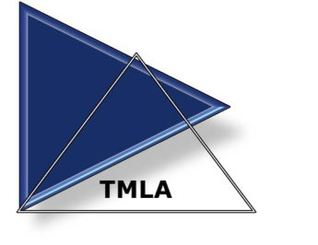

Mail to: Donna Deck, First Citizens Bank, 4004 N. Roxboro St., Durham, NC 27704

Regular Membership Application

I hereby apply for Membership in the Triangle Mortgage Lenders’ Association, enclosing my check for initiation fees in the amount of $245.00, which is to be returned to me in the event of non-election. I understand that I can enroll (3) from the same company for a discount rate of $595 per (3) persons. I have provided ___ other applications to complete our company enrollment. Payments received after 02/15/2020 will be assessed a $25 late fee.

Method of Payment: Check Only

Membership Paid by ____ Member OR ____ Company – Amount Rec’d. ______

(After January, dues will be prorated monthly through December 31st)

Name: _____________________________ Title: _________________________________

Company: _________________________________________________________________

Address: __________________________________________________________________

Business Phone: ___________________ Fax: ___________________
Email: ______________________________________ Date of birth: ________________

Resident of _______________county since ______________, 20________

Please give brief resume’ since entering lending/real estate, including membership in professional societies/organizations, civic organizations, real estate boards, political offices, etc.:

TMLA Pledge:
As a member of the Triangle Mortgage Lender’s Association of Durham and Orange Counties, I pledge to preserve the high moral and ethical standards established by this Association and always engage in activities that help promote the common good of all individuals affected by our respective industries.

If approved for membership, I agree to abide by the by-laws of the association.

Signature of Applicant: ________________________ Date: _______________

Sponsored by: ___________________________________

Signature of TMLA officer: _____________________Date Approved: _______

